LABORATORY WORK #2
Course: Databases
Topic: Normalization and DDL
Student: Saken Aikhanym Nurlankyzy

Normalization

Task 1. Analysis of Booking_receipt
The original unnormalized relation is:
Booking_receipt (booking_id, passenger_full_name, passenger_passport_number, flight_number, departure_airport_name, departure_city, arrival_airport_name, arrival_city, airline_name, seat_numbers, ticket_price)
The table violates First Normal Form (1NF) because the seat_numbers attribute can contain several values in one field, for example "12A, 12B". In 1NF, every attribute must contain only one atomic value.
The table also has problems related to 2NF and 3NF because information about passengers, flights, airports and airlines is stored repeatedly in the same table. This creates data redundancy and may cause update, insertion and deletion anomalies.
The main problematic attributes are:
seat_numbers — contains multiple values;
passenger_full_name depends on the passenger;
airport names and cities depend on airport information;
airline_name depends on the airline;
flight information depends on the flight.
This analysis follows the Booking_receipt structure and multi-valued seat_numbers described in the assignment.

Step-by-Step Normalization
The database is normalized from the original Booking_receipt relation to 1NF, 2NF and finally 3NF, as required.

First Normal Form — 1NF
To achieve 1NF, all attributes must contain atomic values. Therefore, the comma-separated seat_numbers attribute is divided so that each seat is stored separately as seat_number.
BOOKING_RECEIPT_1NF
booking_id
passenger_passport_number
passenger_full_name
flight_number
departure_airport_name
departure_city
arrival_airport_name
arrival_city
airline_name
seat_number
ticket_price
Primary Key: (booking_id, passenger_passport_number)
Now every field contains only one value.

Second Normal Form — 2NF
To achieve 2NF, attributes that depend only on part of the composite key are separated into different tables.
BOOKING
booking_id — PK
flight_number
ticket_price
PASSENGER
passenger_passport_number — PK
passenger_full_name
BOOKING_PASSENGER
booking_id — PK, FK
passenger_passport_number — PK, FK
seat_number
FLIGHT_INFO
flight_number — PK
departure_airport_name
departure_city
arrival_airport_name
arrival_city
airline_name
This removes partial dependencies from the original relation.

Third Normal Form — 3NF
To achieve 3NF, transitive dependencies are removed. Airport and airline information are stored in their own tables.
PASSENGER
passenger_passport_number — PK
passenger_full_name
AIRPORT
airport_id — PK
airport_name
city
AIRLINE
airline_id — PK
airline_name
FLIGHT
flight_number — PK
departure_airport_id — FK
arrival_airport_id — FK
airline_id — FK
BOOKING
booking_id — PK
flight_number — FK
ticket_price
BOOKING_PASSENGER
booking_id — PK, FK
passenger_passport_number — PK, FK
seat_number
The resulting structure is in 3NF because information about passengers, airports, airlines, flights and bookings is separated into appropriate relations.

Functional Dependencies
The following functional dependencies were used during normalization:
booking_id → flight_number
booking_id → ticket_price

passenger_passport_number → passenger_full_name

flight_number → departure_airport_name
flight_number → arrival_airport_name
flight_number → airline_name

departure_airport_name → departure_city
arrival_airport_name → arrival_city

airline_id → airline_name

(booking_id, passenger_passport_number) → seat_number
These dependencies are used to identify partial and transitive dependencies and to divide the original table into normalized relations. The assignment specifically requires listing the functional dependencies used in Task 2.

Checking the Flights Table for 3NF
The primary key of the Flights table is:
Primary Key: flight_id
The main functional dependency is:
flight_id →
sch_departure_time,
sch_arrival_time,
departing_airport_id,
arriving_airport_id,
departing_gate,
arriving_gate,
airline_id,
act_departure_time,
act_arrival_time,
created_at,
updated_at
The Flights table is in Third Normal Form (3NF).
Airport details are not stored directly inside the Flights table. Instead, departing_airport_id and arriving_airport_id reference the Airport table.
Similarly, airline details are not stored directly in Flights. The airline_id attribute references the Airline table.
Therefore, there is no transitive dependency between non-key descriptive attributes inside the Flights table.
This directly addresses the assignment's requirement to check the Flights table for 3NF and consider possible dependencies through departing_airport_id and airline_id.

Implementation of 3NF Tables
The normalized 3NF database structure was implemented in PostgreSQL using CREATE TABLE statements.
The following tables were created:
Passenger_3NF
Airport_3NF
Airline_3NF
Flight_3NF
Booking_3NF
Booking_Passenger_3NF
Primary keys and foreign keys were used to establish relationships between the tables.
At least five sample records were inserted into the tables using INSERT INTO statements, as required by the task.
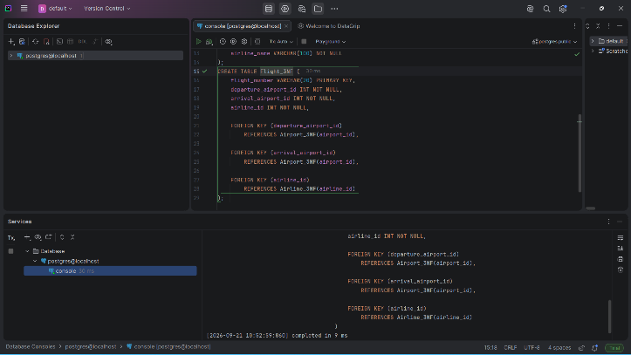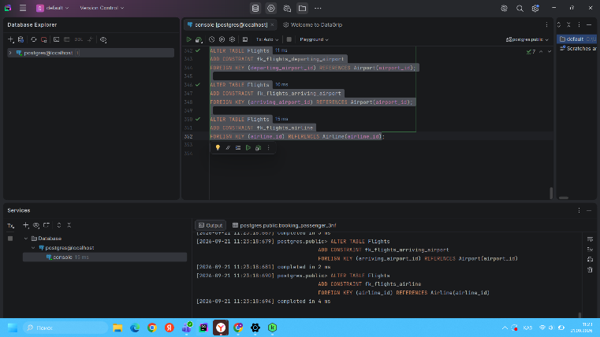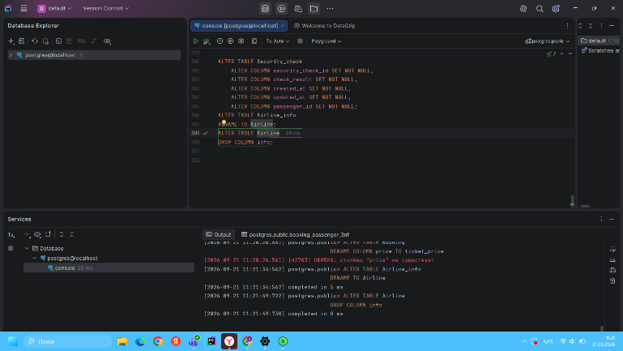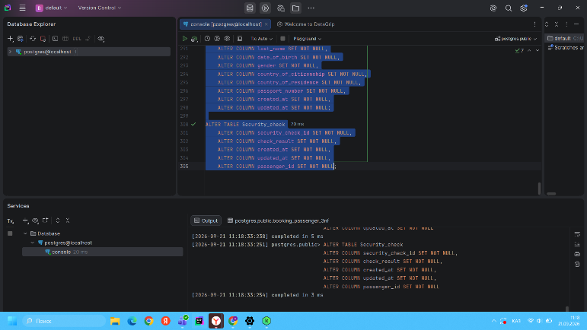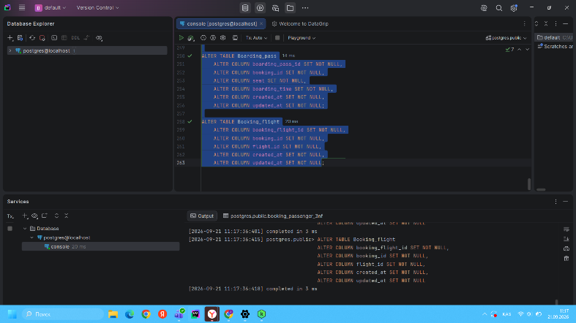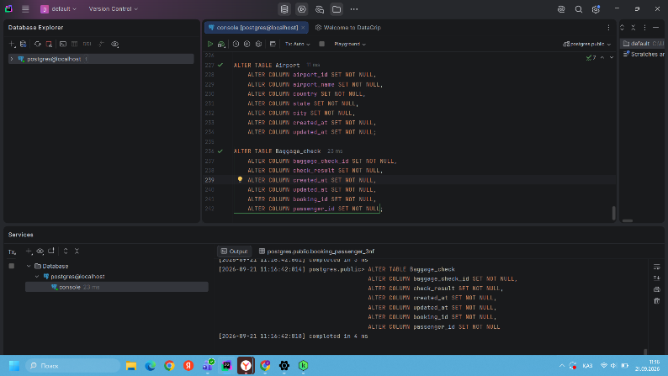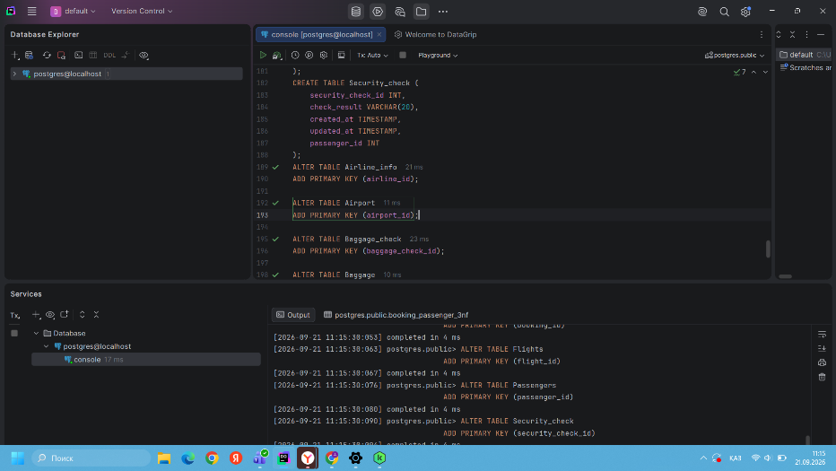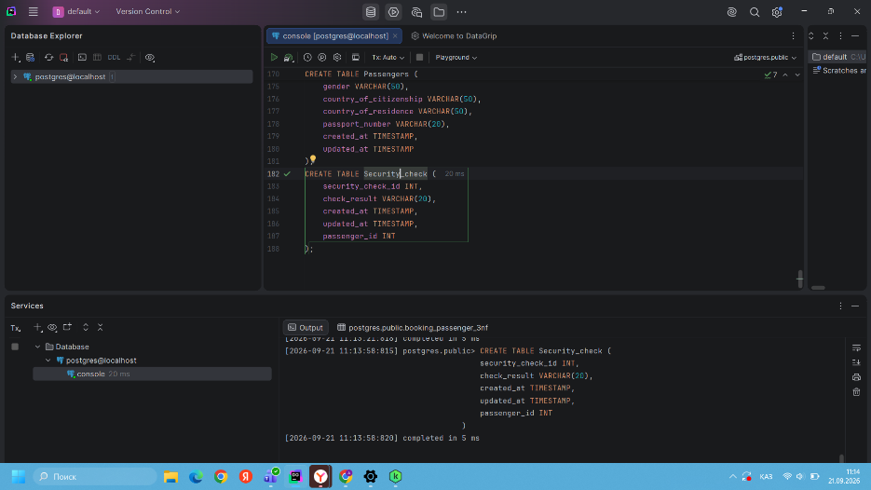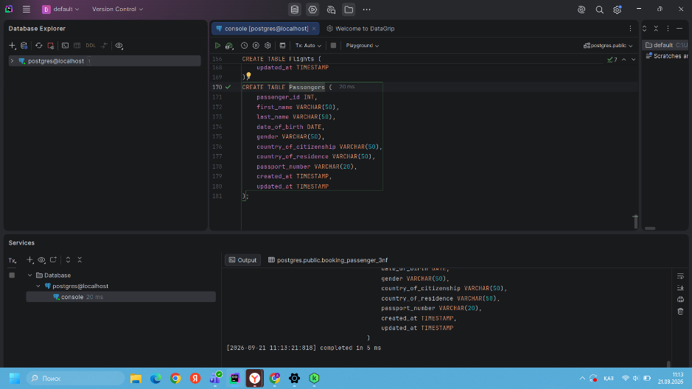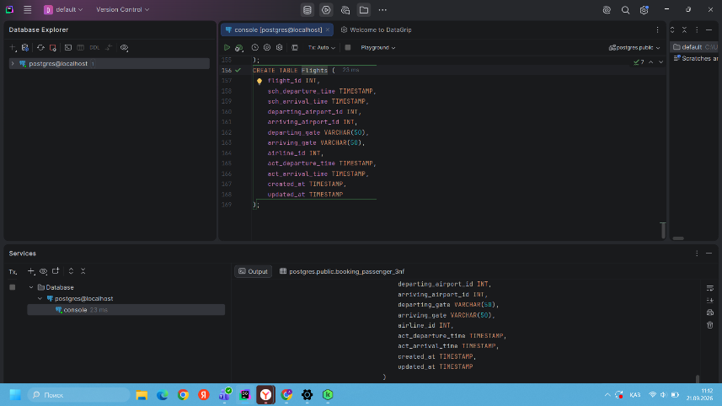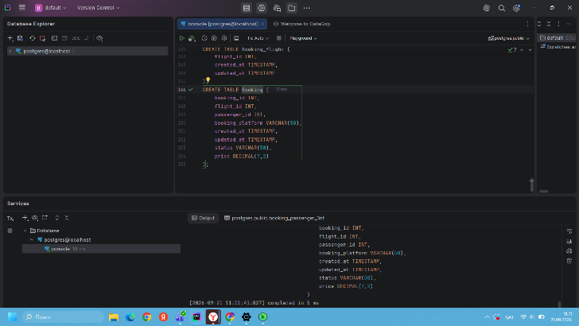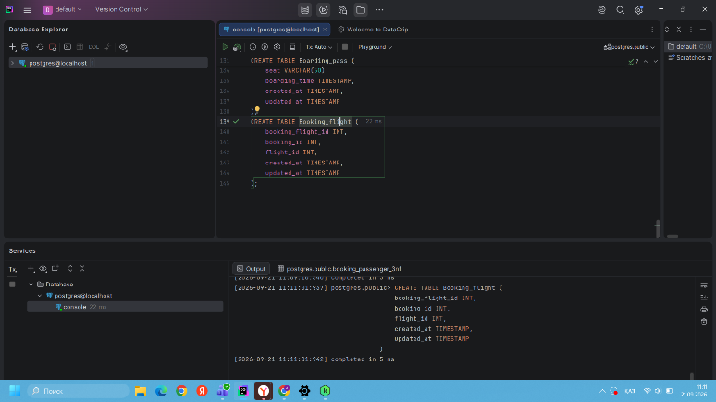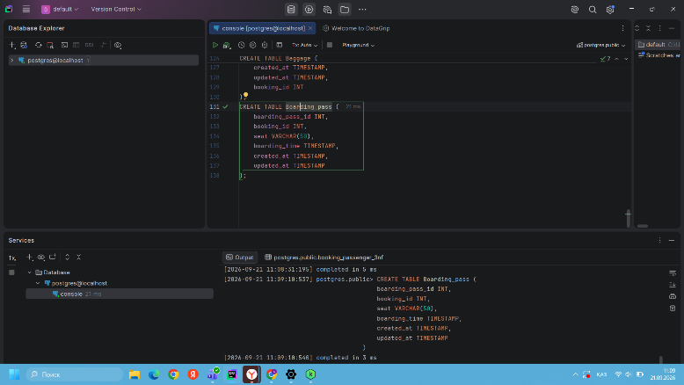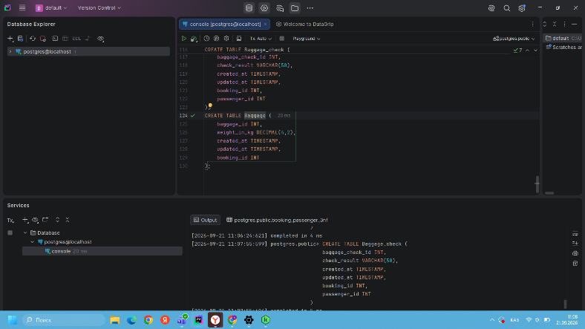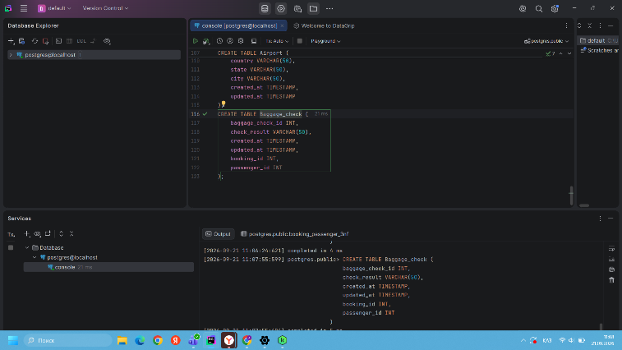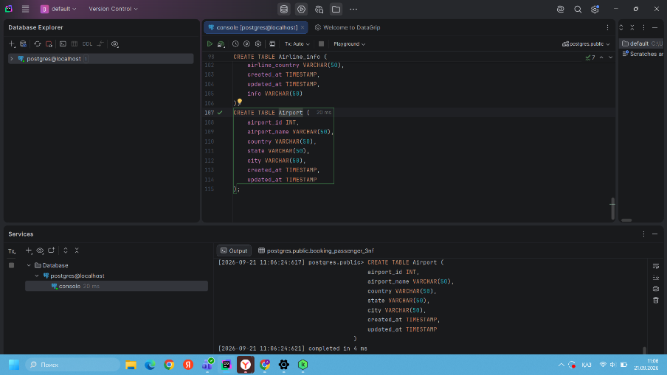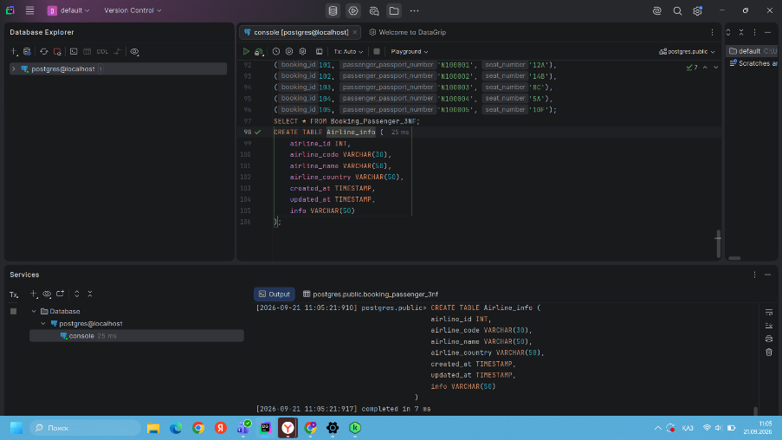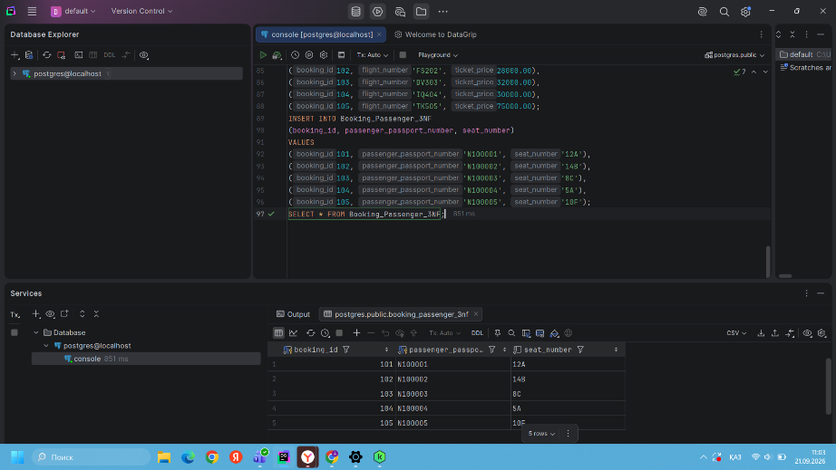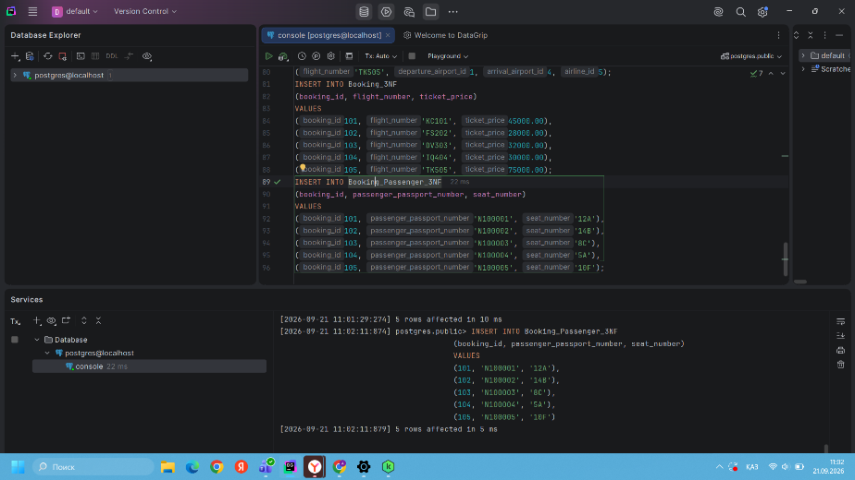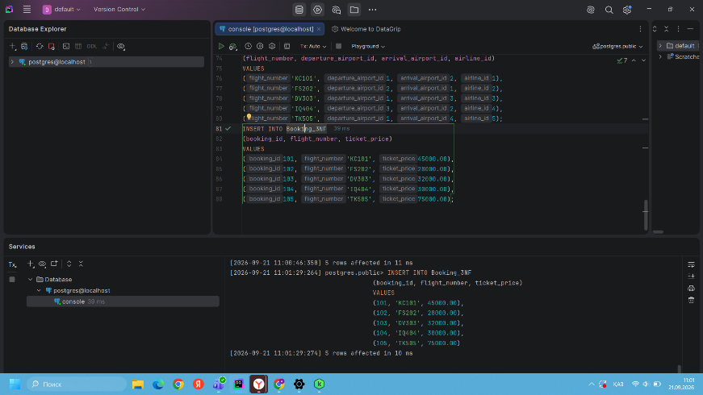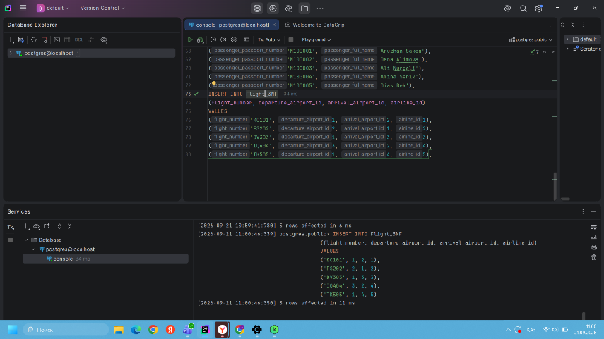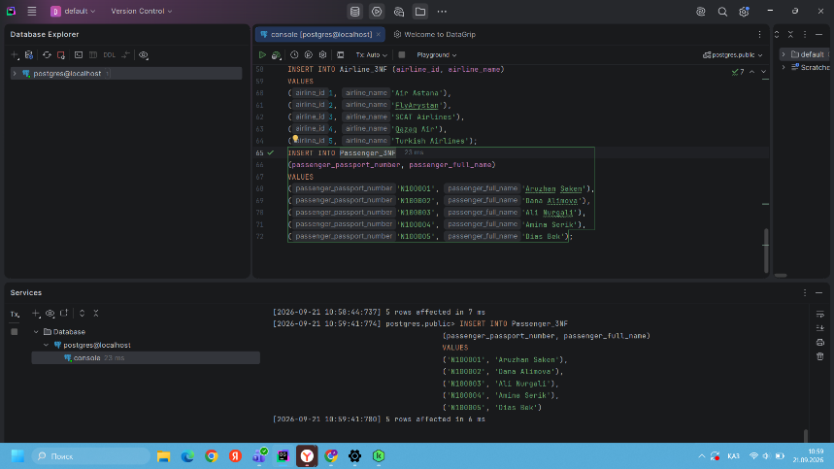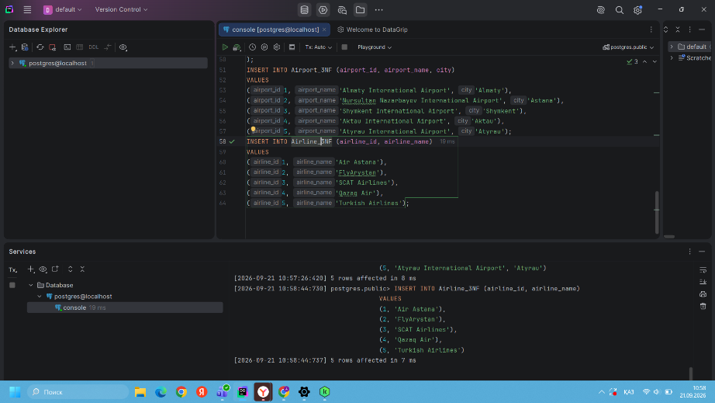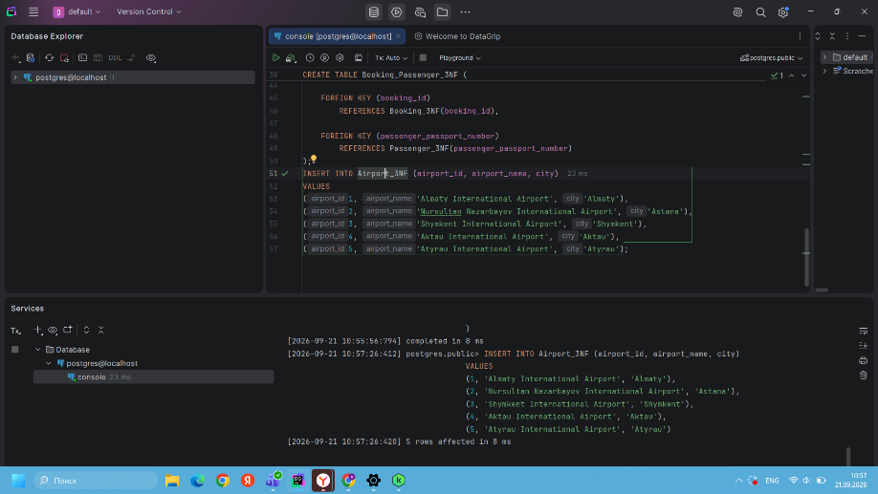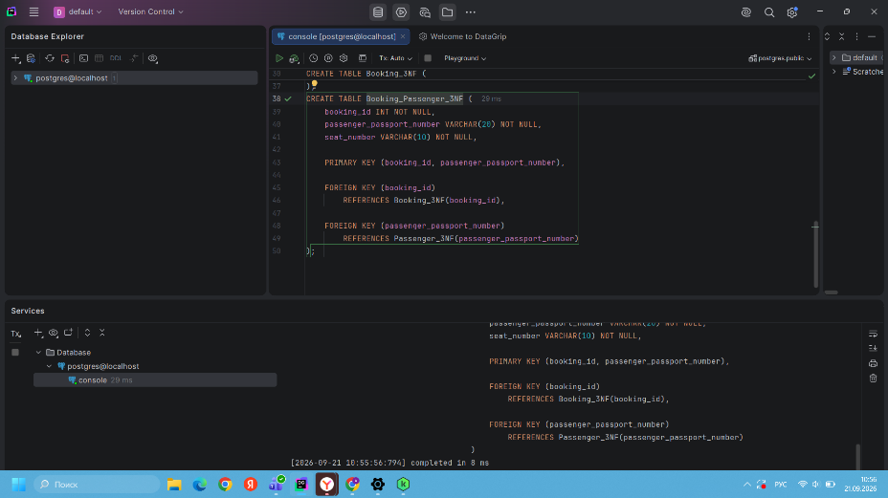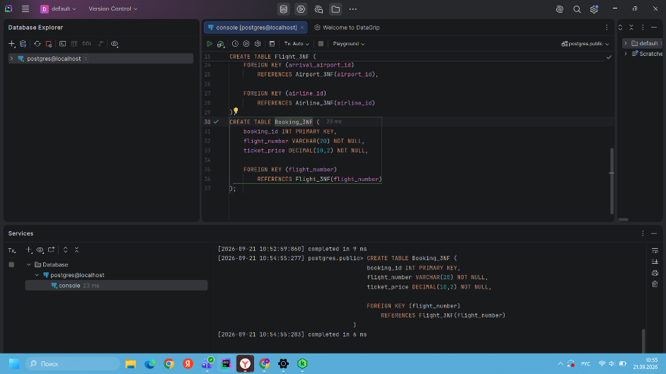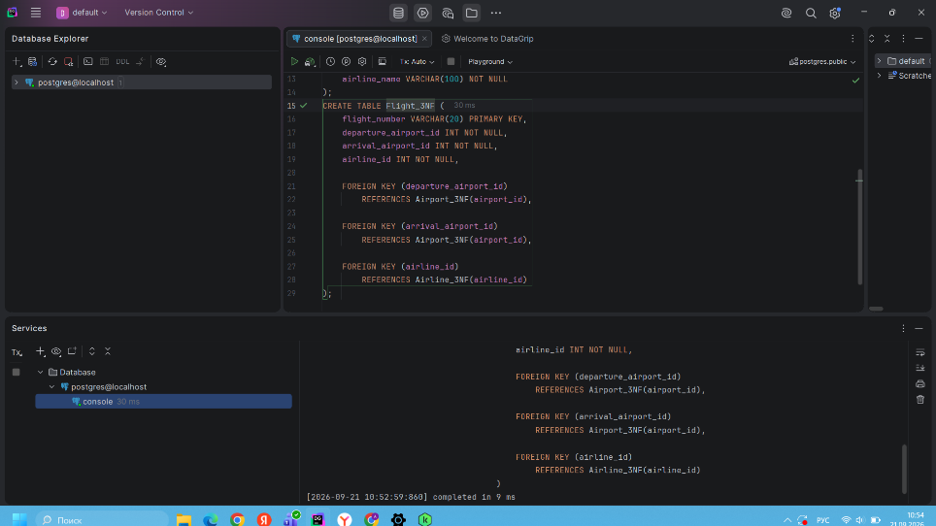

DDL — Creation of Database Tables
The following database tables were created according to the specified structure:
Airline_info
Airport
Baggage_check
Baggage
Boarding_pass
Booking_flight
Booking
Flights
Passengers
Security_check
The tables contain the required attributes and corresponding PostgreSQL data types such as INT, VARCHAR, DECIMAL, DATE, and TIMESTAMP.

Primary Keys
Primary keys were defined for all created tables to uniquely identify each record.
Airline_info — airline_id
Airport — airport_id
Baggage_check — baggage_check_id
Baggage — baggage_id
Boarding_pass — boarding_pass_id
Booking_flight — booking_flight_id
Booking — booking_id
Flights — flight_id
Passengers — passenger_id
Security_check — security_check_id
Primary keys ensure entity integrity and prevent duplicate identification values. The assignment requires primary keys to be defined for each table.

NOT NULL Constraints
NOT NULL constraints were applied to the attributes of the database tables.
The purpose of the NOT NULL constraint is to prevent required attributes from containing NULL values and to improve data integrity.
The constraints were added using:
ALTER TABLE table_name
ALTER COLUMN column_name SET NOT NULL;
The assignment requires NOT NULL constraints for all attributes.

Renaming the Airline Table
The Airline_info table was renamed to Airline.
ALTER TABLE Airline_info
RENAME TO Airline;
This operation changes the table name without deleting its existing structure. This rename is explicitly required by the DDL task.

10. Renaming the Price Column
The price column in the Booking table was renamed to ticket_price.
ALTER TABLE Booking
RENAME COLUMN price TO ticket_price;
This provides a more descriptive name for the price of the booked ticket.

11. Changing the Data Type of departing_gate
The data type of the departing_gate attribute in the Flights table was changed from VARCHAR(50) to TEXT.
ALTER TABLE Flights
ALTER COLUMN departing_gate TYPE TEXT;
This operation changes the data type while preserving the column.

2. Dropping the info Column
The info column was removed from the renamed Airline table.
ALTER TABLE Airline
DROP COLUMN info;
After this operation, the info attribute is no longer part of the Airline table.
Tasks 9–12 correspond to the required rename, type-change, and drop operations in the assignment.

3. Foreign Key Relationships
Foreign keys were added to establish relationships between the database tables.
The following relationships were implemented:
Passengers → Security_check by passenger_id
Passengers → Booking by passenger_id
Passengers → Baggage_check by passenger_id

Booking → Baggage_check by booking_id
Booking → Baggage by booking_id
Booking → Boarding_pass by booking_id
Booking → Booking_flight by booking_id

Flights → Booking_flight by flight_id

Airport → Flights by departing_airport_id
Airport → Flights by arriving_airport_id

Airline → Flights by airline_id
These relationships maintain referential integrity between related records in the database and correspond to the relationships specified in the assignment.

Conclusion
In this laboratory work, database normalization and DDL operations were performed using PostgreSQL and DataGrip.
The original Booking_receipt relation was analyzed and normalized step by step from 1NF to 2NF and 3NF. Functional dependencies were identified, and the Flights table was checked for compliance with Third Normal Form.
The normalized database tables were implemented using SQL CREATE TABLE statements and populated with sample data. In the DDL section, the required airport database tables were created, primary keys and NOT NULL constraints were defined, table and column names were modified, a column data type was changed, an unnecessary column was removed, and foreign key relationships were established.
As a result, the database structure provides better data organization, reduces redundancy, and maintains entity and referential integrity.

